Create a folder called notes-class and inside of it create a file named README.md containing 3 interesting ideas you have learned today and then:

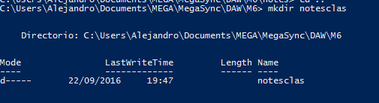





* initiliaze a git repository





* add this new file to the repo



* commit the change



* add 2 more interesting ideas to the README.md



* add this new file to staging

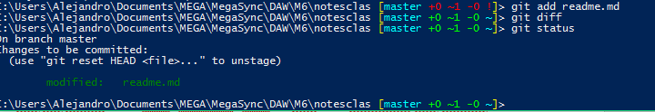

* commit this new change



* check the log of commits

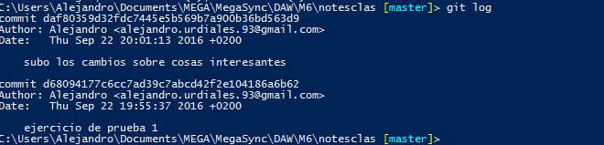

* Create a remote repo on github called notes-classes

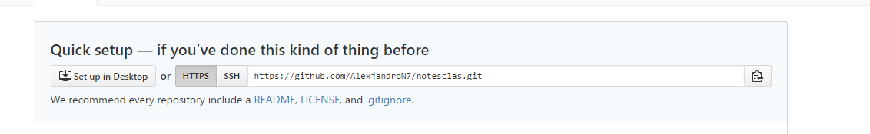

* Add this remote repo (git remote add) to your local repopush your changes to the remote repo



* add 4 more interesting ideas to the README.mdadd & commit your change to the local repo



* sync w/ the remote repo (pushing your latest changes)

